Resistor:-

A device used to control current in an electric circuit by providing resistance.

Resistance:--

The act or an instance of resisting or the capacity to resist.

**2.** A force that tends to oppose or retard motion.

A measure of the degree to which a substance impedes the flow of electric current induced by a voltage. Resistance is measured in ohms. Good conductors, such as copper, have low resistance. Good insulators, such as rubber, have high resistance. Resistance causes electrical energy to be dissipated as heat.

Ohms law:---

The law stating that the direct current flowing in a conductor is directly proportional to the potential difference between its ends. It is usually formulated as *V* = *IR,* where *V* is the potential difference, or voltage, *I* is the current, and *R* is the resistance of the conductor.

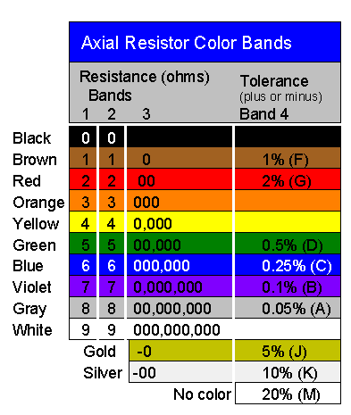

Capacitor:--

An electric circuit element used to store charge temporarily, consisting in general of two metallic plates separated and insulated from each other by a dielectric. Also called *condenser*.

A **capacitor** (originally known as a **condenser**) is a [passive](http://en.wikipedia.org/wiki/Passivity_%28engineering%29) [two-terminal](http://en.wikipedia.org/wiki/Terminal_%28electronics%29) [electrical component](http://en.wikipedia.org/wiki/Electronic_component) used to store [energy](http://en.wikipedia.org/wiki/Energy) [electrostatically](http://en.wikipedia.org/wiki/Electrostatic) in an [electric field](http://en.wikipedia.org/wiki/Electric_field). The forms of practical capacitors vary widely, but all contain at least two [electrical conductors](http://en.wikipedia.org/wiki/Electrical_conductor) separated by a [dielectric](http://en.wikipedia.org/wiki/Dielectric) ([insulator](http://en.wikipedia.org/wiki/Insulator_%28electricity%29)); for example, one common construction consists of metal foils separated by a thin layer of insulating film. Capacitors are widely used as parts of [electrical circuits](http://en.wikipedia.org/wiki/Electrical_circuit) in many common electrical devices.

An ideal capacitor is wholly characterized by a constant [capacitance](http://en.wikipedia.org/wiki/Capacitance) *C*, defined as the ratio of charge ±*Q* on each conductor to the voltage *V* between them:[[10]](http://en.wikipedia.org/wiki/Capacitor#cite_note-Ulaby_p168-10)

C= \frac{Q}{V}

Inductor:--

One that inducts, especially a device that functions by or introduces inductance into a circuit.

An **inductor**, also called a **coil** or **reactor**, is a [passive](http://en.wikipedia.org/wiki/Passivity_%28engineering%29) [two-terminal](http://en.wikipedia.org/wiki/Terminal_%28electronics%29) [electrical component](http://en.wikipedia.org/wiki/Electronic_component) which resists changes in [electric current](http://en.wikipedia.org/wiki/Electric_current) passing through it. It consists of a conductor such as a wire, usually wound into a [coil](http://en.wikipedia.org/wiki/Coil_%28electrical_engineering%29). When a current flows through it, [energy](http://en.wikipedia.org/wiki/Energy) is stored temporarily in a [magnetic field](http://en.wikipedia.org/wiki/Magnetic_field) in the coil. When the current flowing through an inductor changes, the time-varying magnetic field induces a [voltage](http://en.wikipedia.org/wiki/Voltage) in the conductor, according to [Faraday’s law of electromagnetic induction](http://en.wikipedia.org/wiki/Faraday%27s_law_of_induction), which opposes the change in current that created it.

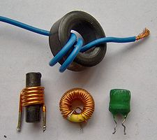

[Inductance](http://en.wikipedia.org/wiki/Inductance) (*L*) results from the [magnetic field](http://en.wikipedia.org/wiki/Magnetic_field) around a current-carrying [conductor](http://en.wikipedia.org/wiki/Electrical_conductor); the [electric current](http://en.wikipedia.org/wiki/Electric_current) through the conductor creates a [magnetic flux](http://en.wikipedia.org/wiki/Magnetic_flux). Geometrically speaking, the inductance of a coil depends on many factors including its shape, cross-sectional area, number of turns, spacing between turns, and the permeability of the core material to name a few. Mathematically speaking, inductance is determined by how much [magnetic flux](http://en.wikipedia.org/wiki/Magnetic_flux) *φ* through the circuit is created by a given current *i*

L = {\phi \over i} \,